## *Mission Rwanda 15 – 24 April 2024*

## Scientific repport

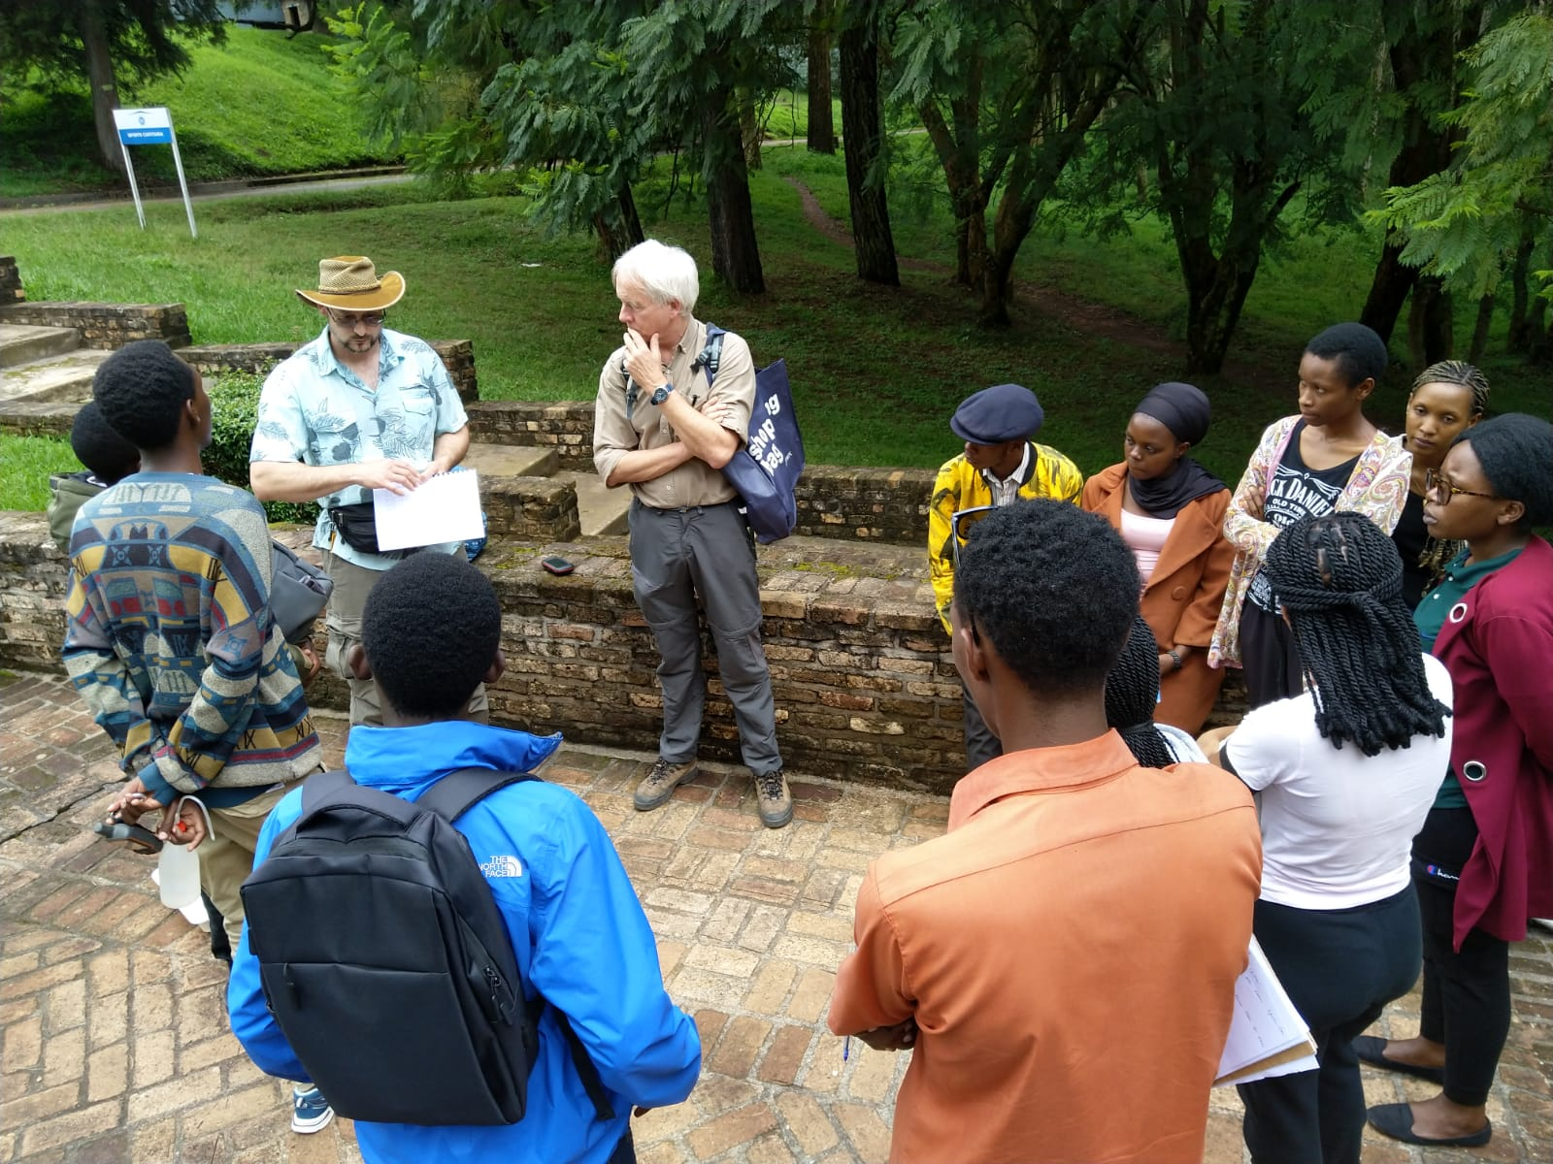

Aurore Mathys

Arnaud Henrard

Franck Theeten

Didier Van den Spiegel

**Background**

Collections of natural history reflect both the unique worldwide biodiversity of past and present life and the geological history of the Earth. It is estimated that European Natural history (NH) collections contain up to 1 billion specimens. When used at their full potential, NH collections are able to contribute to understanding and mitigation of critical challenges such as biodiversity loss, climate change, invasive species or the vectors of diseases. The collections of the Africa Museum (RMCA), the Royal Belgian Institute of Natural Sciences (RBINS) and the federal collection of Meise Botanic Garden (MBG) form together the richest collection (estimation of about 10 million specimens and more than 100000 type specimens) related to Central Africa due to the colonial history of Belgium.

There is a strong need to give access or provide to overseas countries the FAIR access to this unique collection.

**CANATHIST**

CANATHIST, an INFRA-FED project started in 2023, aims produce the most complete inventory of the collections collected during the colonial period among the Belgian DiSSCo institutions and non-DiSSCo scientific institutions as research infrastructure, make a provenance study, prioritize the digitization of the collections (data, metadata and digital specimens) and share all information, digital specimens and archives with the competent authorities, institutions and citizen communities of DRC, Burundi and Rwanda, using a specific collaborative infrastructure and/or dedicated offline tools (Collection Management systems, 2D Images server, 3d object server, Map server and Annotation server (text and image) ).

**Objectif**

Ensure the participation of Rwanda (unfunded partners) in the integration of the tools mentioned above through specific training and technology transfer.

**Presentation given and Trainings**

During the stay the following presentations have been given, all available on <https://canathist.naturalheritage.be/>

1. Introduction to CANATHIST
2. Introduction to the CMS DaRWIN
3. Introduction to Virtualcoll
4. Digitisation of the collections

Training

* How to collect soil arthropods : from field to collection
* QGIS

**Site**

# *Location of Rwanda in Africa (a). Map of Rwandan forests showing the two research sites: the Nyungwe forest and Ruhande Arboretum (© Donat Nsabimana, 2009)*

*A,B: presentation at CoEB; C, D : training on how to collect soil arthropods*

**Agenda**

|  |  |  |  |  |  |  |  |  |
| --- | --- | --- | --- | --- | --- | --- | --- | --- |
|  | **Mon 15/04** | **Tue 16/04** | **Wed 17/04** | **Thu 18/04** | **Fri 19/04** | **Fri 19/05** | **Fri 19/06** | **Fri 19/07** |
| **8h30-10h30** | Flight to Kigali | Travel Kigali-Huye | Presentation of the CMS DaRWIN, and Importation Template | Presentation of digitisation methods and Virtual Collection | QGIS and Forest Layers |  |  | Meeting with veterinarian Olivier Nsengimana at Umusambi Village |
| **10h30-12h** | Cartographic tools with DaRWIN. Comparison with SYMBIOTA | Presentation of QGIS for creating Distribution Map | Discussion on the need of the UR and presentation of the Central Africa GBIF portal |  |  | Visit of the research center and the Grey Crowned Cranes sanctuary at Umusambi Village |
| **12h-13h** | Lunch time | Lunch time | Lunch time | Lunch time |  |  | Lunch time |
| **13h-14h30** | Welcome at Huye abd CoEB, introdution to the team, visit | Demonstration of sampling methods to collect spiders and Diplopods in the Arboretum | Use of the collection sampled in the Arboretum as case study to test the CMS and Virtual Collection | Back to Kigali |  |  | Flight to Brussels |
| **14h30-16h30** | Visit of the CoEB, facilities and collections |
| **Evening** | Arrival at Kigali | / | Night collecting (20h-22h)? | / |